|  |  |  |
| --- | --- | --- |
| National Sorority of  Phi Delta Kappa, Inc. | **Undergraduate Scholarship Application 2023**  Application MUST be submitted through the  Local Chapter Scholarship Chairperson to be considered | Scholarship Form **007** |
| **2022 - 2023** |

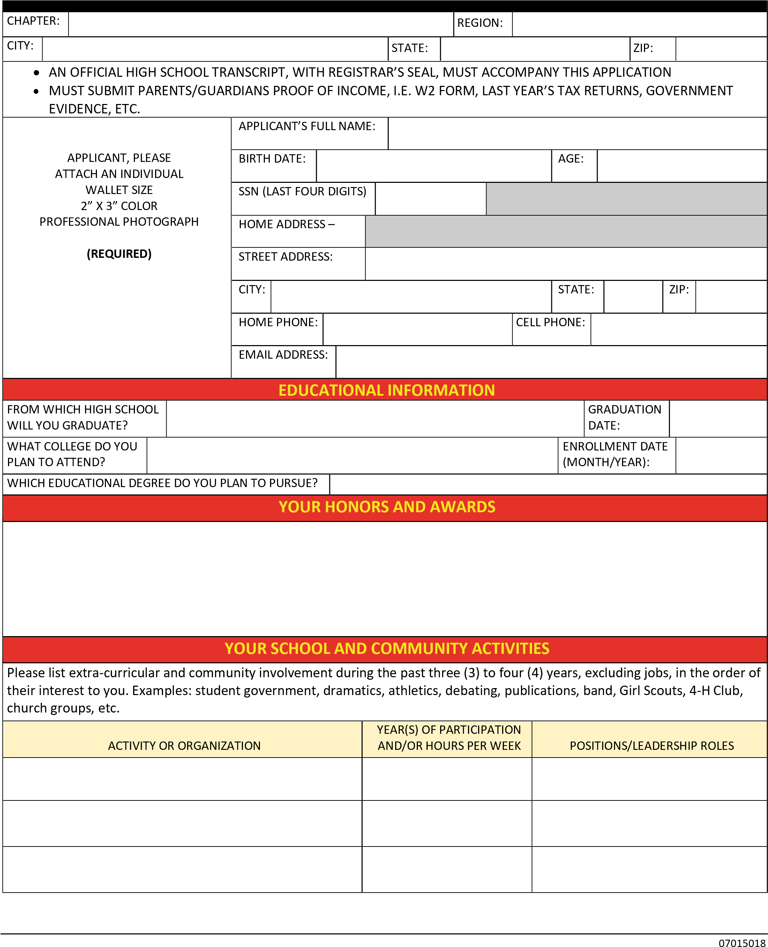

Page 2 SF **007** (2020-2021)

|  |  |  |  |  |  |  |  |  |  |  |  |  |  |  |  |  |  |  |  |  |  |  |  |  |  |  |  |  |  |
| --- | --- | --- | --- | --- | --- | --- | --- | --- | --- | --- | --- | --- | --- | --- | --- | --- | --- | --- | --- | --- | --- | --- | --- | --- | --- | --- | --- | --- | --- |
|  | | | | | | | | | | | | | | |  | | | | | | | | |  | | | | | |
|  | | | | | | | | | | | | | | |  | | | | | | | | |  | | | | | |
|  | | | | | | | | | | | | | | |  | | | | | | | | |  | | | | | |
|  | | | | | | | | | | | | | | |  | | | | | | | | |  | | | | | |
| **YOUR FAMILY** | | | | | | | | | | | | | | | | | | | | | | | | | | | | | |
| PARENT OR GUARDIAN’S NAME: | | | |  | | | | | | | | | | | |  | PARENT OR GUARDIAN’S NAME: | | | |  | | | | | | | | |
| OCCUPATION: | | | | |  | | | | | | | | | | | OCCUPATION: | | | | |  | | | | | | | |
| STREET: | | |  | | | | | | | | | | | | | STREET: | | |  | | | | | | | | | |
| CITY: |  | | | | | | | | | | | | | | | CITY: |  | | | | | | | | | | | |
| STATE: | |  | | | | | | | | | | | ZIP: |  | | STATE: | |  | | | | | | | | ZIP: | |  |
| **\*** ANNUAL INCOME $: | | | | | | | |  | | | | | | | | **\*** ANNUAL INCOME $: | | | | | |  | | | | | | |
| HOW MANY DEPENDENT CHILDREN, INCLUDING YOURSELF, ARE SUPPORTED BY YOUR PARENTS OR GUARDIANS? | | | | | | | | | | | | | | | | | | | | | | | | | |  | | | |
| **\*** *Proof of income, i.e. W2 form, last year’s tax returns; statement of income from appropriate government agency, employer, verification of homeless status/unemployment or child support, etc. Applications will not be scored without required documentations***.** | | | | | | | | | | | | | | | | | | | | | | | | | | | | | |
| **LETTERS OF RECOMMENDATIONS** | | | | | | | | | | | | | | | | | | | | | | | | | | | | | |
| Two (2) letters of recommendation with original signature required, one of which must be from a school official. | | | | | | | | | | | | | | | | | | | | | | | | | | | | | |
| NAME: | | |  | | | | | | | | | | | | |  | NAME: | | |  | | | | | | | | | |
| TITLE: | | |  | | | | | | | | | | | | |  | TITLE: | | |  | | | | | | | | | |
|  | | | | | | | | | | | | | | | | | | | | | | | | | | | | | |
| **VALIDATION FORM** | | | | | | | | | | | | | | | | | | | | | | | | | | | | | |
| I did receive and fully understand the **Rules, Regulations**, and **Eligibility Requirements** of the undergraduate scholarship which is for applicants who are pursuing studies in the field of education. I further understand all documentation becomes the property of the National Sorority of Phi Delta Kappa, Incorporated; and, my photo may be used for publication. | | | | | | | | | | | | | | | | | | | | | | | | | | | | | |
| APPLICANT’S SIGNATURE: | | | | | | | | |  | | | | | | | | | | | | | | | | DATE: | | |  | |
| PARENT’S/GUARDIAN’S SIGNATURE: | | | | | | | | |  | | | | | | | | | | | | | | | | DATE: | | |  | |
| LOCAL SCHOLARSHIP CHAIR NAME: | | | | | | | | | | |  | | | | | | | | | | | | | | | | | | |
| LOCAL SCHOLARSHIP CHAIR SIGNATU | | | | | | | | | | | RE: |  | | | | | | | | | | | | | DATE: | | |  | |
| CHAIR EMAIL: | | | | | |  | | | | |  | | | | | | | | | | | | | | | | | | |
| BASILEUS NAME: | | | | | | |  | | | |  | | | | | | | | | | | | | | | | | | |
| BASILEUS SIGNATURE: | | | | | | | | | |  |  | | | | | | | | | | | | | | DATE: | | |  | |

# UPDATED 11/2021